**Post Item**

Test Case 1 <single>

Size : Empty

Test Case 2 <single>

Number : X>=0

Test Case 3 <error>

Content : Not a number

Test Case 5 <single>

Value : Zero

Test Case 12 (Key = 2.0.1.2.1.3.1.1.1.2.2.2.)

Size : Not empty

Number : <n/a>

Content : Is a number

Value : Zero

Format : Two decimal places

Value : >= dollar more

Format : Two decimal places

Value : Zero

Format : Two decimal places

Presence of description : Not empty

Presence of category : Not empty

Presence of user logged in : True

**Bid**

Test Case 1 (Key = 1.1.1.1.)

Content : is a number

Format : two decimal places

Value : amount >= price + 1

Max amt : amount <= maxBid

Test Case 2 (Key = 1.1.2.1.)

Content : is a number

Format : two decimal places

Value : amount <= price + 1

Max amt : amount <= maxBid

Test Case 3 (Key = 1.2.1.1.)

Content : is a number

Format : not two decimal places

Value : amount >= price + 1

Max amt : amount <= maxBid

**White Box**

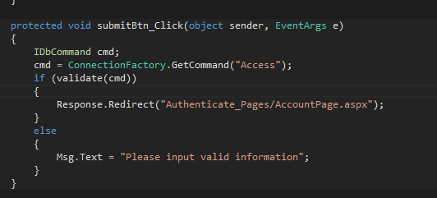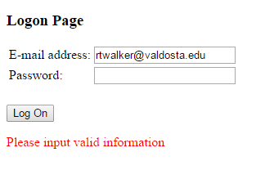Test case:  
Email: [rtwalker@valdosta.edu](mailto:rtwalker@valdosta.edu)  
password: (invalid input)